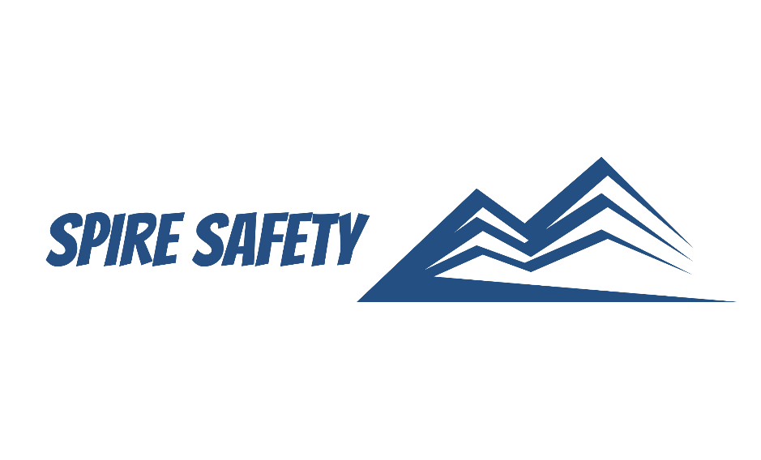

WORKING AT HEIGHTS PROCEDURE

SS-WHS-PRO-000

DOCUMENT HISTORY

|  |  |  |  |  |
| --- | --- | --- | --- | --- |
| rev | date | Description | | approved by |
|  |  |  |  |  |
|  |  |  |  |  |
|  |  |  |  |  |
|  |  |  |  |  |
|  |  |  |  |  |

|  |
| --- |
|  |
|  |
| Phone: |
| Email: |
| Address: |
|  |
| **DISCLAIMER** |
| While every effort has been made to ensure the accuracy, completeness, and reliability of the information presented, we make no representations or warranties of any kind, express or implied, regarding the content or suitability of this document for any particular purpose. The contents of this document are confidential, privileged, and provided expressly for intended recipients’ use only. This document may not be used, published, or redistributed without prior consent. |

Contents

1 Purpose 3

2 Scope 3

3 Working at Heights Procedure 3

3.1 Hazard Identification and Risk Assessment 3

3.2 Training and Competency 3

3.3 Working at Heights Methodologies 3

3.3.1 Working at Heights Less than 2m 3

3.3.2 Working at Heights Over 2m 3

3.3.3 Use of Ladders 4

3.4 Selection, Inspection and Maintenance of Equipment 5

3.5 Emergency Preparedness 5

4 Reference Documents 5

# 1 Purpose

The purpose of this Working at Heights Procedure is to establish guidelines and practices for the safe execution of tasks that involve working at heights. The procedure aims to protect employees, contractors, and other personnel from the risks associated with working at elevated locations, ensuring compliance with relevant regulations and industry best practices.

# 2 Scope

This procedure applies to all employees, contractors, and personnel who perform tasks or activities that involve working at heights within our organisation. It covers all work locations and premises under our control, including construction sites, industrial facilities, offices, and any other areas where work at heights is conducted.

# 3 Working at Heights Procedure

## 3.1 Hazard Identification and Risk Assessment

Working at heights risks are managed in accordance with the risk management procedure with hazards, risks and controls measures recorded within the WHS Risk Register*.* Identification of working at heights hazards is also conducted through WHS Inspections.

## 3.2 Training and Competency

Training programs are tailored to the specific type of working at heights, its associated risks, and the individual's role and responsibilities. Competency assessments and refresher training are conducted regularly to ensure ongoing competency and adherence to safe work practices. All records of training are recorded in the Training Register.

## 3.3 Working at Heights Methodologies

### 3.3.1 Working at Heights Less than 2m

For working at heights less than 2m, general risk control measures are undertaken to eliminate or minimise the likelihood of a fall and reduce the severity of consequences if a fall were to occur. Examples of these control measures include:

* Working from the ground, if possible,
* Using suitable working at heights equipment (e.g., not standing on chairs or other equipment to gain access),
* Ensuring equipment is inspected prior to use,
* Conducting risk assessments to reduce the risk of a fall, and
* Ensuring the ground around the working at heights area is clear of debris or other objects that may cause a fall and more serious injuries.

### 3.3.2 Working at Heights Over 2m

We consider work over 2m as “high-risk work” requiring a physical barrier to stop the worker from falling or, if this is not possible, a fall restraint or arrest harness to protect them in the event of a fall.

#### 3.3.2.1 Access and Egress

Safe access and egress points are established for working at heights, ensuring that personnel can safely move to and from elevated locations. Stairways, ladders, and access equipment are properly installed, secured, and maintained. Adequate lighting, signage, and markings may be provided to guide personnel and minimise the risk of slips, trips, and falls.

#### 3.3.2.2 Hierarchy of Controls

As per the WHS regulations, we employ the “working at heights hierarchy of controls” to manage the risks of working at heights, which include (in order):

* Performing the work from ground level,
* Performing the work off a solid construction (e.g., work platform or scaffolding),
* Providing fall prevention devices (e.g., a handrail),
* Providing work positioning systems (e.g., fall restraint harness), or
* Providing fall arrest systems (e.g., catch nets or fall arrest harness).

#### 3.3.2.3 Dropped Items

Drop zones are to be established where there is risk of falling objects. Clear signage and markings are installed to indicate the boundaries of the drop zone and provide visual cues for personnel working at heights. This includes warning signs, barricades, and floor markings to alert individuals to the presence of a drop zone and to prevent unauthorized entry.

Tool lanyards are also be supplied to workers where there is a risk of tools or equipment being inadvertently dropped, and kickboards are installed on scaffolding or other exposed edges where a tool or piece of equipment may be inadvertently “kicked” over the edge.

## 3.3.3 Use of Ladders

The following controls are implemented when selecting and setting up ladders:

* Using ladders that are industrial-rated and inspected for damage or defects prior to use,
* Ensuring the ladder is the correct height for the work to avoid over-reaching or stretching,
* Locking devices on the ladder are secure,
* Ensuring the ladder has non-slip feet,
* Placing extension ladders at a slope of 4:1, and
* Securing ladders at the top or bottom, or if necessary, at both ends.

When using ladders, the following controls are implemented:

* Always maintaining ‘three points of contact’,
* Using a tool belt or side pouch so that materials or tools are not carried in the hands while climbing the ladder,
* Ensuring only light duty work is carried out while on the ladder, where tools can be operated safely with one hand,
* Making sure that no-one works underneath the ladder,
* Not allowing anyone else on the ladder at the same time,
* Not straddling the ladder, and
* Wearing slip-resistant footwear.

## 3.4 Selection, Inspection and Maintenance of Equipment

Procurement of working at heights equipment is done in accordance with the procurement procedure. Factors such as the height involved, nature of the work, weight capacity requirements, and environmental factors are considered during the equipment selection process. This ensures that the chosen equipment is suitable for the intended purpose and can safely support workers at heights.

A thorough inspection process is established to verify the safety and integrity of working at heights equipment. This includes conducting pre-use inspections to identify any defects, damage, or signs of wear that could compromise the equipment's performance or pose a risk to workers. Regular inspections are also conducted to ensure ongoing equipment safety and compliance. Working at heights equipment is subjected to periodic testing and tagging in line with regulatory requirements.

## 3.5 Emergency Preparedness

Emergency preparedness is done in accordance with the site-specific Emergency Response Plan or SWMS / SWPs*.* In particular, consideration is given to situations where “fall arrest” systems are in use, including ensuring that:

* Adequate communications system is in place,
* A plan is in place and is rehearsed to rescue a fallen worker (within 5 minutes if they are subject to suspension trauma),
* Staff are trained in the emergency procedures, and
* Rescue gear is readily available and fit-for-purpose.

# 4 Reference Documents

The following documents are referenced within this procedure:

* NA