TASK | EWP
HAZARDS | Flying debris | ☐ | Heat / cold | ☐ | Electricity | ☒
 | Cuts / laceration | ☐ | Dust | ☐ | Tip Over | ☒
 | Pinch / crush | ☐ | Noise / vibration | ☐ | Plant interaction | ☒
 | High pressure | ☐ | Falling | ☒ | Entrapment | ☒
PPE REQUIRED | 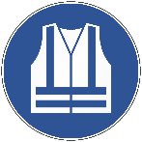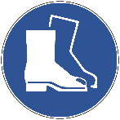
PRE-START CHECKS
- Inspect the EWP for any visible damage, leaks, or defects.
- Complete all pre-start checks as per manufacturer’s guidelines.
- Check the stability of the ground and ensure it can support the weight of the EWP.
- Verify that all safety features, such as guardrails and emergency stop buttons, are functional.
- Confirm that all controls and systems are operational by performing a test lift and lowering.
SAFE OPERATING PROCEDURE
- Ensure personnel are competent and authorized.
- Ensure personnel are fit for duty and not impaired by drugs or alcohol.
- Do not use a mobile phone while operating and always wear your seatbelt.
- Operate at a safe speed and maintain exclusion zones around people, powerlines, and other hazards (use spotters if necessary).
- Beware of uneven or sloping ground.
- Use the provided harness and attach to the designated anchor point before ascending.
- Lower the platform completely and secure it before exiting the EWP.
POST-OPERATION PROCEDURE
- Lower the platform to the ground and turn off the EWP.
- Perform a final visual inspection for any damage or debris.
- Secure the EWP and return it to the designated storage area.
- Report any issues or incidents encountered during operation to the appropriate personnel.

